Parade Entry Form
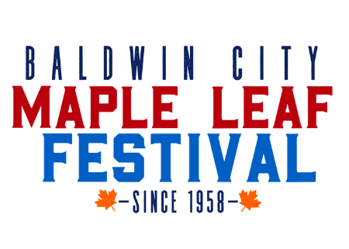
Maple Leaf Festival - October 19th, 2024
Parade Theme:
“Turn a New Leaf”
The 67th Annual Maple Leaf Festival

Times and Locations:
The parade will begin at 11:00 am. Formation for the parade begins at 9:00 am at the east edge of Baldwin City near the corner of US 56 Highway and High Street (Hillside for Floats).
ARRIVE NO LATER THAN 10:30 AM
HORSE AND HORSE DRAWN ENTRIES will meet at the soccer fields at 3rd and Orange streets.

ENTRIES FOR THE 67th ANNUAL MAPLE LEAF FESTIVAL PARADE
MUST BE SUBMITTED BY OCTOBER 10, 2024!
YOU MUST FILL OUT A NO FAULT FORM TO BE ELIGIBLE TO PARTICIPATE IN THE PARADE

Please select a type of entry:

Float ______ Band ______ Car ______ Horse ______ Other ___________________________________________

Name of Organization or Company: ________________________________________________________________________________

Director or Person in Charge: ________________________________________________________________________________

Address: ________________________________________________________________________________

________________________________________________________________________________

Telephone Number: ________________________________________________________________________________

Email: ________________________________________________________________________________

Approximate number of persons: ____________ Approximate number of vehicles __________

Do you wish to include your float entry in the judging of the theme competition? _______ Yes _______ No
***IF YOU WISH TO BE JUDGED FLOATS MUST BE READY BY 10 AM!!!***
Description: (Enter the information you want announced from the reviewing stand. Please attach additional pages if needed)

For the safety of the parade spectators and the parade participants we must ask that NO CANDY be thrown or handed out during the parade. Our concern is children running into the street to collect candy and being hit by moving vehicles.

Mail completed form to: Maple Leaf Festival, PO Box 564 Baldwin City, KS 66006 or to mapleleafparade@gmail.com

**FREQUENTLY ASKED QUESTIONS**

How do I know my line up in the Parade?
If you register as a float entry you will line up on Highway 56 and Hillside on the east side of Baldwin. A Parade director will give you your line up number at that time.
If you register as a car entry you will line up on Highway 56 and High Street on the east side of Baldwin. A Parade director will give you your line up number at that time.
If you register as a horse entry you will line up on 3rd and Orange Street on the south side of Baldwin. A Parade director will give you your line up number at that time.

What is the Parade Route?
The parade starts at 3rd and High Street and turns north on 6th Street to Chapel.

Can I throw Candy?
No candy or other articles may be thrown during the parade. You may walk alongside of your float by the curb and hand out these items to the spectators. If this rule is violated you will not be eligible to participate in the parade the following year.

Can my entry be judged?
Yes and there is a 1st place, 2nd place and 3rd place award. Below are the judging criteria:
25 POINTS. . . . . .Interpretation of Parade Theme
20 Points. . . . . .Originality of Design
15 Points. . . . . .Originality of Material Used
10 Points. . . . . .Use of Material and Colors
10 Points. . . . . .Use of Total Area of Vehicle and Float
10 Points. . . . . .Integrated Use of Organization's Theme and Members
5 Points. . . . . .General Overall Visual impression of Float
5 Points. . . . . .Spirit and Enthusiasm of Participants on Float

Where can I unload my entry off of my trailer?
North 250 RD (north of Highway 56 and High Street).

Where can I park to walk to my entries staging number?
Santa Fe Drive and 1st Street

